Buy Illegal « Zone »

Welcome to the installation guide for the script **Buy Illegal « Zone »**. This script required the **Core Framework** to work correctly.

**Installation**

Open your **missionlife.**

Copy the enclosed folder "**illegal_stuff**" into "**MissionName.Map\armapps**". The folder structure should now be "**MissionName.Map\armapps\illegal_stuff**".

Include and done.

Include in this file : **aan_master.cpp**

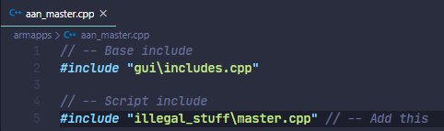

Include in this file : **aan_functions_master.cpp**

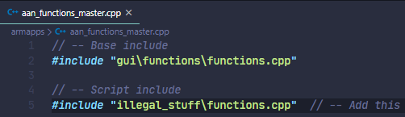

You can delete the **docs** folder